Use Case Realisation Report - Manage ProjectRaise Interest
FOR
Volunteer Management System
(VMS)

CLIENT
PROJECT | Volunteer Management System (VMS)
TITLE | Use Case Realisation Report - Manage ProjectRaise Interest
VERSION | 0.1a
DATE | 13-Aug-2011
 | ORIGINATOR
 | Name / Signature | Team 8S
 | APPROVAL
 | Name / Signature | Phung Kim Cuong, Dio
Institute of Systems Science |  | Document Reference
25 Heng Mui Keng Terrence  Singapore 119615 |  | VMS/PM-1.3.1/1

 | Acceptance
 | Customer Signature |  | Customer Signature
 | Name & Designation |  | Name & Designation
 | Date & Company Stamp |  | Date & Company Stamp

Revision History

Date | Version | Description | Author
12-Jun-2011 | 0.1a | Creation | Team 8S
 |  | Refer to amendment history

Table of Contents

1. Brief Description 3
2. Flow of Events 3
2.1 Standard Flow 3
2.2 Exceptions 3
3. Interaction Diagrams 4
3.1 Domain Collaboration Diagram: Raise Interest 4
4. Participating Objects 4
5. Derived Requirements 4
6. Derived Requirements 4
ANNEX D Amendment History 4

Use-Case Realization Report
Raise Interest

Brief Description
The use case enables registered user to propose new project.

Flow of Events
The standard flow of events for this use case and any exceptions are described in the following subsections. See section 3.1 for an overview of the participating Actors and Domain Objects.

Standard Flow

Precondition: Volunteer has logged in the system and use case 4.6 has been executed

This use case provides the user interface related functionality that will be provided to the User, as follows:
- When the Volunteer clicks ‘raiseInterest’ button on the ProjectDeatilsScreen, the raiseInterest() method of ProjectDeatilsScreen is triggered.
- ProjectDeatilsScreen uses the method addProjectInterest() of ProjectController to create a new request.
- ProjectController will first fetch the projected from the Project Object by using method getprojectId()
- Then ProjectController will use the create() method of ProjectInterest object to create an new instance with userId and projected
- Finally, the ProjectController will display a message on the ProjectDetailsScreen to notify the user that a new request has been sent for Project Manager approval.

Exceptions
The following exceptions have been identified:
- Invalid Information Format. If any of input info is incompatible, system will give a validation summary for user to make corrections

Interaction Diagrams

Domain Collaboration Diagram: Raise Interest
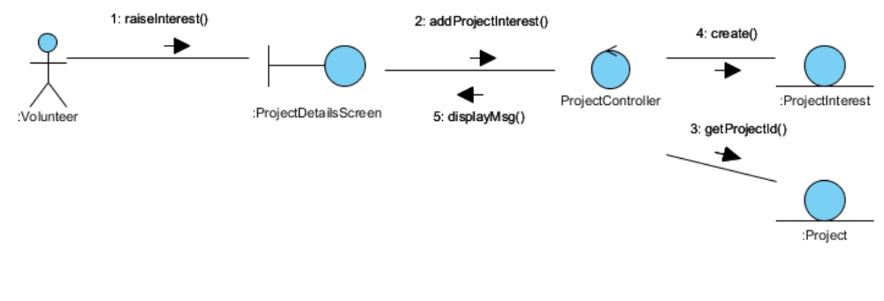

Participating Objects
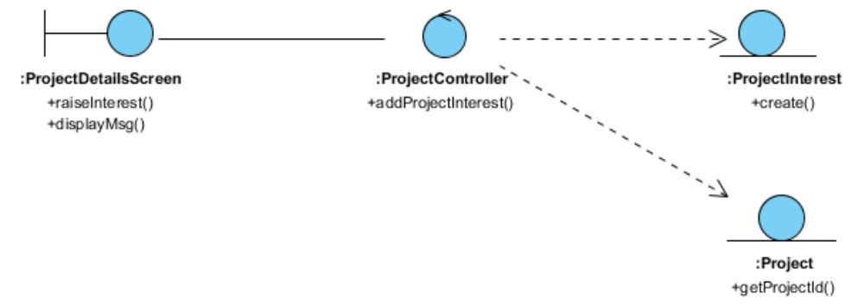
:

Derived Requirements

:

Derived Requirements

ANNEX D Amendment History

This is a record of all amendments made to the Document.
Version | Chapter / Section | Page No | Notes of Amendments or Changes

